4.22: The reaction to the upward normal force on the passenger is the downward normal force, also of magnitude 620 N, that the passenger exerts on the floor. The reaction to the passenger’s weight is the gravitational force that the passenger exerts on the earth, upward and also of magnitude 650 N. 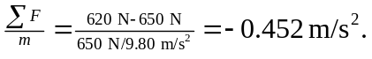 The passenger’s acceleration is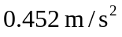, downward.

